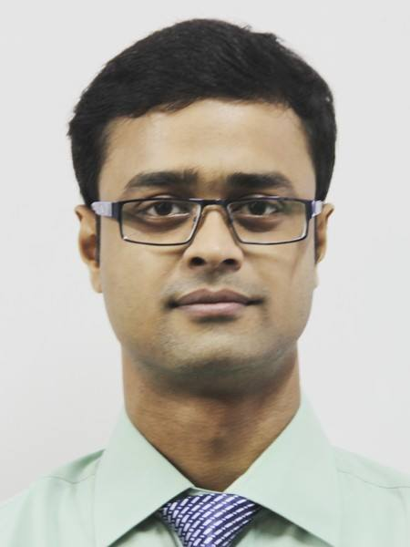**SK SAMIM AKHTAR**

**Experience of 23months:**

6months- Cyber Q Consulting Pvt. Ltd

(Project of Haldia Dock Complex, A Govt Enterprise)

17months- Amarnath dyeing and Bleaching Works Pvt. Ltd

|  |
| --- |
| **CAREER OBJECTIVES** |

To work in an esteemed organization that provides opportunities to grow up by

exploring the unconventional avenues.

|  |
| --- |
| **EDUCATIONAL QUALIFICATION** |

# 

|  |  |  |  |  |
| --- | --- | --- | --- | --- |
| **Academic Level** | **Year of Passing** | **Institute** | **Board/University** | **Percentage** |
| MBA  (FINANCE) | 2014 | School Of Management Sciences | Indian Institute Of Engineering Science and Technology, Shibpur | 66%  (Upto 3rd semester) |
| B-Tech  ( ECE) | 2010 | Haldia Institute Of Technology, Haldia | West Bengal University Of Technology | 7.37 |
| HIGHER SECONDARY | 2003 | Anantapur Siddheswari High School(H.S) | West Bengal Council of Higher Secondary Education | 63% |
| MADHYAMIK | 2001 | Ajodha Belpukur High School | West Bengal Board of Secondary Education | 69% |

###### 

|  |
| --- |
| **WORK EXPERIENCE** |

**Total experience: 23 months**

Company: Cyber Q Consulting Pvt. Ltd.

Client: **Haldia Dock Complex, Shipping Corporation of India, a Govt Enterprise.**

Designation: Programmer (Network system administration).

Duration: - 6 months.

Project: - PLC maintains and installation (Operation management).

Client: - **Amarnath dyeing and Bleaching Works Pvt. Ltd, Anantapur. Howrah**,

Designation: Control Engineer.

Duration: - 17 months

|  |
| --- |
| **COMPUTER PROFICIENCY** |

* Certificate in Linux System Administration by IBM.
* Microsoft Office Package.

|  |
| --- |
| **PROJECTS** |

***POST GRADUATION:***

|  |  |
| --- | --- |
| **Organization** | **Project Name** |
| INDIAN INSTITUTE OF ENGINEERING SCIENCE AND TECHNOLOGY,SHIBPUR | PERFORMANCE ANALYSIS OF DIFFERENT CATAGORIES OF BANKS IN INDIA(NPA) |
| Indian Oil Corporation | WORKING CAPITAL MANAGEMENT- Analysis of balance sheet. |
| State Bank Of India | Study to find out challenges faced by small farmers in access to banking facilities. |

***GRADUATION:***

|  |  |
| --- | --- |
| **Organization** | **Project Name** |
| INDIAN AIRLINES (NACIL) | EMERGENCY LOCATOR TRANSMITTER:  Description of Project: It is a Indian Airlines project in Kolkata in India. This project is to install and replacement of the Emergency Locator Transmitter (ELT). This ELT helps to find the plane’s location. It is placed in the Indian Airlines.  Involved in: Installation and replacement of battery and ELT itself |

|  |
| --- |
| **PERSONAL INFORMATION** |

Father’s Name: SK MD MAHASIN

Date of Birth: 24TH April, 1986

Gender: MALE

Marital Status: SINGLE

Languages Known: BENGALI, ENGLISH, HINDI.

Hobbies: Cooking, Photography.

**CONTACT DETAILS:-**

**Mobile No**. **+91-9007203133**

**Email**: **samimakhtar.24@gmail.com**

Permanent Address:

VILL+PO= AJODHYA,

PS=SHYAMPUR,

DIST=HOWRAH,

PIN=711312

|  |
| --- |
| **EXTRA CURRICULAR ACTIVITIES** |

* Participated in Seminar titled “Resurgence of Business Through Education led Initiative”, organized by BESU SHIBPUR
* Took part in B-Quiz and Ad-Making at college annual function.
* Took part in organizing AURORA (MBA Fest BESU)
* Active participation in the cultural programs at school and college.
* Was active member in RIVERA (B-tech College Fest) .

|  |
| --- |
| **DECLARATION** |

.

I hereby declare that the above written particulars are true to the best of my knowledge and belief.

**Date: …………………………..** _________________________

**Place: ………………………….** (SK SAMIM AKHTAR)